**BACKEND: MERN STACK BOOTCAMP**

**Assignment No: 02**

**Name: Romaisa Amjad**

**Date: 6/4/2025**

**Question:**

Create a basic web server using core Node JS that can listen to requests and response to it. The server should have the following responses on different routes

1. /: Return a heading and a paragraph.
2. **GET: /product:**Return a form having an input field of **ProductName**and **ShopName**.
3. Hit **POST: /product**on form submission to send a post request to **/product**
4. **POST /product:**Parse the request data and save it in a file and also return html showing that data.

Handle the rest of routes by sending **404**status code and **Page Not Found**response.

**Code Implementation:**

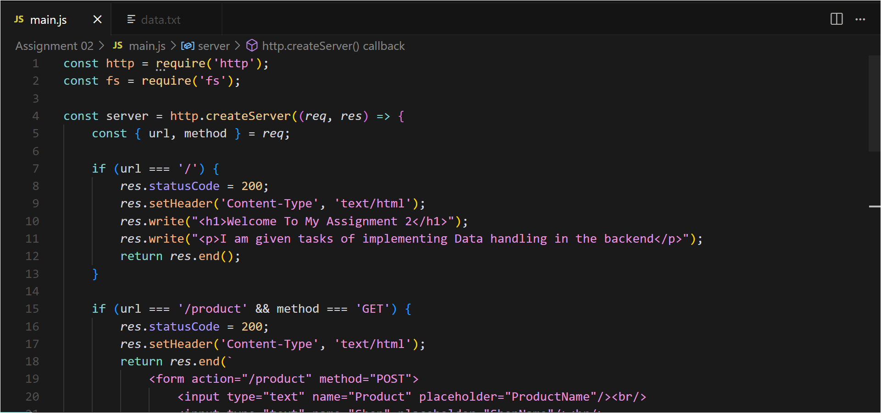

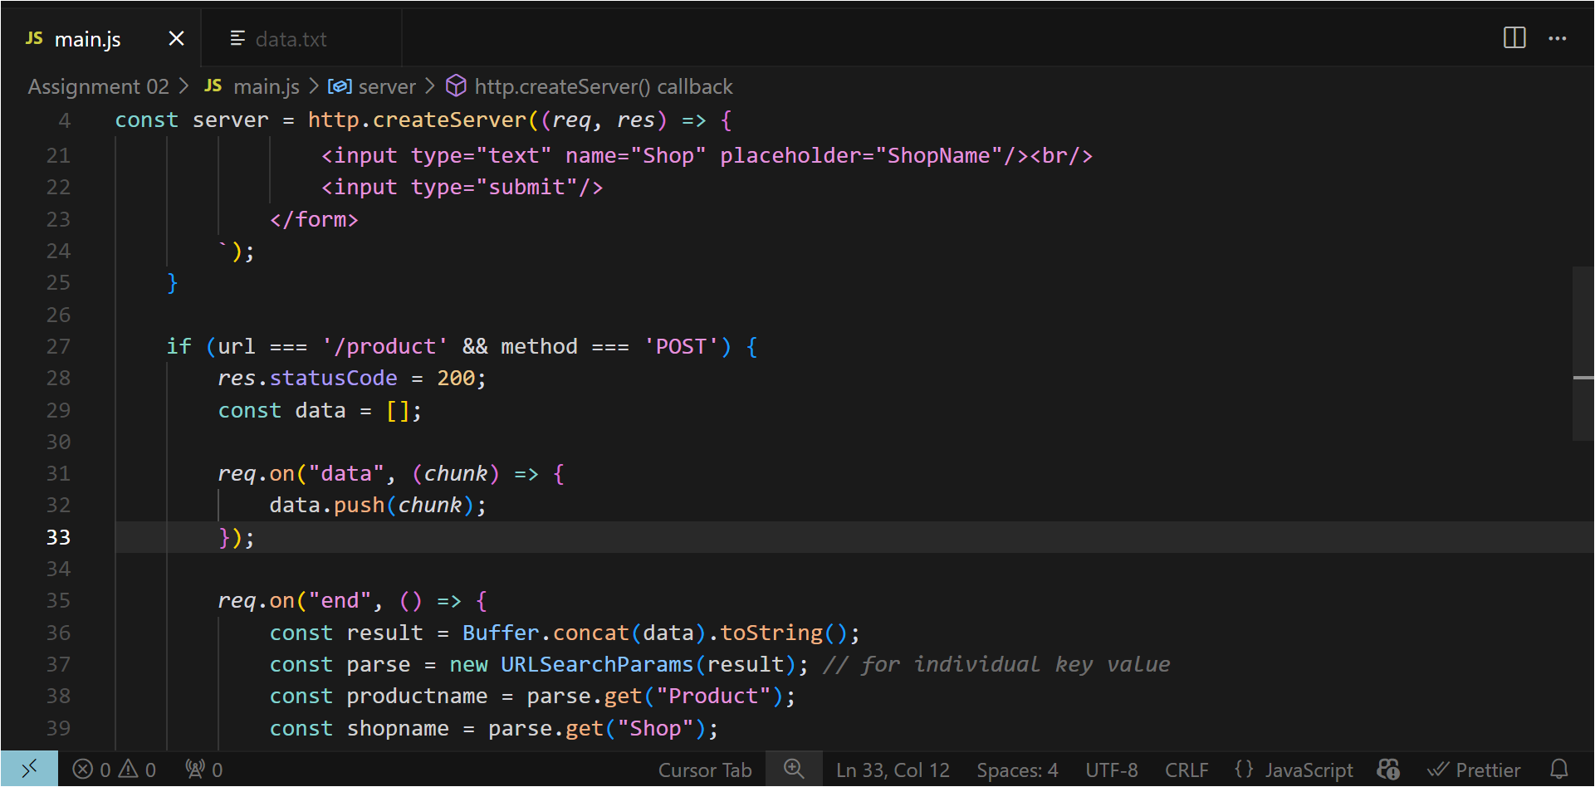

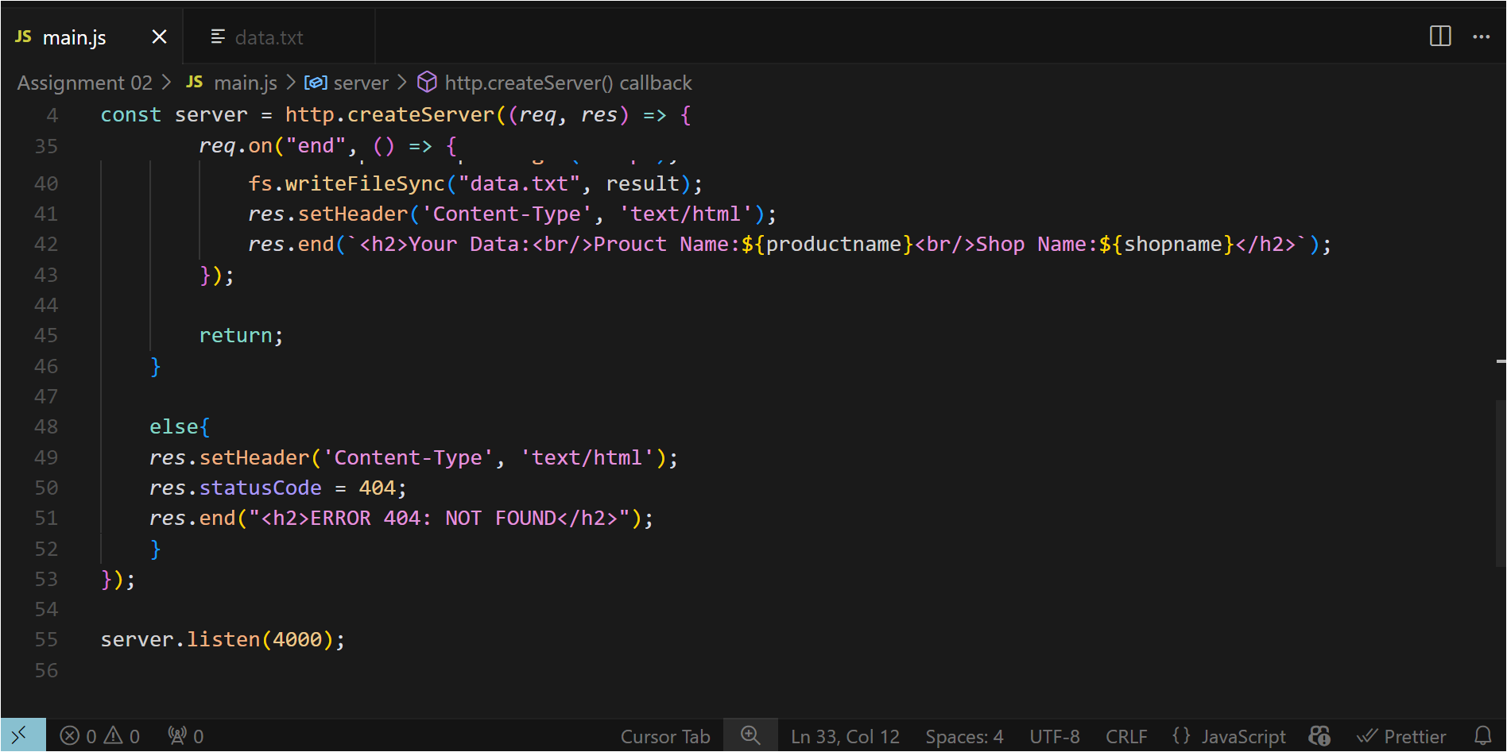

**Output:**

